Number 48 September, 2019

DKG@UN in Connecticut
SDG Toolkit of Links
History- Good introduction of MDGs & SDGs – Stop at 2:38 mins https://www.youtube.com/watch?v=Q-HHIczsAGM

Transitioning from the MDGs to the SDGs - UNDP (3:02 mins) https://www.youtube.com/watch?v=5_hLuEui6ww
About the SDGs – video (1:24 mins) and interactive SDG icons https://www.un.org/sustainabledevelopment/sustainable-development-goals/
United Nations – Why the Goals Matter https://www.un.org/sustainabledevelopment/why-the-sdgs-matter/

What is Sustainable Development? - video (3:40 mins) https://www.youtube.com/watch?v=7V8oFI4GYMY

The Road to the SDGs: A discussion with students (6:41 mins) https://www.youtube.com/watch?v=ZZzBbO6Y0uc
The World’s Largest Lesson Part 1 (6:34 mins) https://www.youtube.com/watch?v=a8ozBBMMjtw

The World’s Largest Lesson Part 2 (5:16 mins) https://www.youtube.com/watch?v=lUjYMrGreRw

The World’s Largest Lesson 2019 – video (3:00 mins) https://www.youtube.com/watch?v=cBxN9E5f7pc

https://www.un.org/sustainabledevelopment/blog/category/video-education/

By Ann Grosjean

Last summer, The DKG @ UN Representatives shared the United Nations Sustainable Development Goals (SDGs) with about 350 members from 33 states at the DKG Northeast International Global Awareness Conference held in Connecticut. Primary Representative, Eileen Venezia (NY), introduced the DKG @ UN Representatives and the history of the Global Goals on opening night. The Sustainable Development Goals (SDGs) were highlighted during the general sessions throughout the conference with the DKG @ UN representatives spotlighting each goal and what each person can do to help achieve it. Anne-Marie Carlson (NY), Grace Murphy (NY), Lochie Musso (NY), and Ann Grosjean (CT) each introduced several of the Global Goals # 1- 15.

Connie Rensink (TX) introduced SDG # 16 and facilitated a “Lunch and Learn” panel to discuss Goal # 17 – Partnerships. (See companion article below.) The DKG @ UN Representatives also did a follow-up workshop, Global Goals in Action, to share the progress and areas for improvement for each of the goals to date. To learn more about the goals visit https://www.globalgoals.org
On the right is a SDG Toolkit of Links you can use for self-study, to plan a meeting to introduce the Global Goals, or for classroom lessons.
Also, visit the website below to access colored posters of the seventeen SDG Global Goal icons for web or print.
www.un.org/sustainabledevelopment/news/communications-material/

Partnering to Achieve the Sustainable Development Goals and World Peace
By Connie Rensink
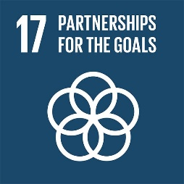
In order to reach the Global Goals, we need everyone to come together – government, civil society, scientists, business, and academia. Partnerships are important because working together increases efficiency and effectiveness. Collaboration can help to use fewer resources and have a larger impact on common challenges.
At the Global Awareness Conference a lunchtime panel focused on SDG 17, Partnership for the Goals. The panel spotlighted representatives who are working across sectors to address global issues.
Business: Kaitlyn Venezia, working on Ranstaad International’s Global Sustainability Team, told how her department collaborates with companies internationally that need global or multi-country support. They train and provide skilled staff who are inter-culturally adept. These efforts support Global Goal 8, Decent Work and Economic Growth.
Civil Society/ Education: Laura Krenicki, a teacher at William J. Johnson Middle School in Colchester, CT. initiated a classroom project called One Day in Our World to get her students interacting with kids across the world to investigate solutions for the Global Goals. To date the project has over 8700 responses and over 69 thousand views. She observed how one-on-one connections build understanding and break down stereotypical misconceptions. The project supports all of the SDGs, particularly Global Goal 4, Quality Education.
Non-Governmental Organization (NGO:) Chris George, Executive Director Integrated Refugee and Immigration Services (IRIS) shared fascinating details about the process and support it takes to resettle refugees in America. His organization partners with and trains community organizations to support the transition of new refugees. IRIS also provides educational workshops about the exhaustive steps each refugee goes through to be vetted for settlement, usually over 2-3 years. This work supports Global Goals 10, Reduced Inequality and 16, Peace, Justice, and Strong Institutions.
Each of the panelists reiterated how vital partnerships are in their work. The examples they shared model how partnerships can improve our chances for achieving the Global Goals.

Can Fashion Be Sustainable?
By Grace Murphy
Would you be willing to buy only eight new wardrobe items per year in order to reduce greenhouse gas emissions? A recent report from “C40 Cities” – a coalition of 100 local governments working to control climate change – offers that suggestion.
Designer Eileen Fisher said, “The clothing industry is the second largest polluter in the world, second only to the oil industry.” Whether this statement is totally correct or not, the fact is that in 2015, 79 billion cubic meters of water (2,000 gallons per pair) were used in the manufacturing of jeans.
So, can fashion be sustainable?
Designers and manufacturers have developed vegetarian leather and faux fur; some refuse to use feathers, fur and exotic skins; companies are working on making plastic reusable, recyclable or compostable; and smaller houses use fabric that is leftover. Levi-Strauss is working on softening hemp so it can be used for jeans. This will be waterless dyeing, but the jeans will cost about $128 per pair.
The average American discards about 80 pounds of clothing and shoes per year and 84% goes into landfills or incinerators. Secondhand clothing anyone?
SDG #12 calls for “Responsible consumption and production.” Is green the new black?
For more on this topic, go to: www.sustainablefashionmatterz.com; www.refinery29.com; and www.greenstrategy.se/en

Welcome, Emilie Stris

DKG@UN would like to thank Ruth Nielsen for her contributions to this sub-committee of EEC. Sadly, Ruth has decided to resign from her position. Emilie Stris has been appointed to take her place on this team. We welcome Emilie and look forward to working with her!

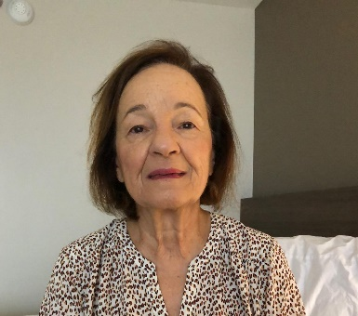
A member of DKG since 2001, Emilie Stris has 37 years of experience in the New York City school system as an elementary teacher, reading coordinator, assistant principal, and professional development specialist.

Emilie has served DKG as chapter president, parliamentarian and area conferences chair as well as chairing New York State Organization committees, World Fellowship and the Verna Mulholland Friend of Education Award.

She is a CTAUN colleague, and active in her community of Valley Stream, New York. She is a founder of the Parkwold Civic Association and a director and a past president of the VS D13 Educational Foundation.

"War No More" - Friday, 28 February 2020
Mark Friday, 28 February 2020 on your calendar and let colleagues know as well. The Committee on Teaching about the United Nations (CTAUN) will honor the UN on its 75th anniversary and call for the continuing implementation of the following words from its 1945 Charter:
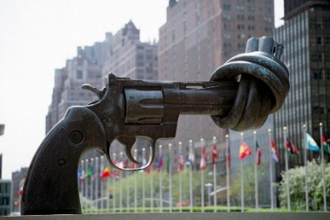
"We the peoples of the United Nations, determined to save succeeding generations from the scourge of war which twice in our lifetime has brought untold sorrow to mankind...."
"The idea of war is obsolete," said Eleanor Roosevelt.
"If we could end Apartheid, why not war?" maintained Bishop Desmond Tutu.
Conference details, including program, registration, and special hotel rates for out-of-town participants, are posted on the CTAUN website: www.teachun.org

YOUR UN REPRESENTATIVES - The DKG members listed below are your official representatives at the UNDGC (UN Department of Global Communications) and the Economic and Social Council (ECOSOC). All of them also work with CTAUN. You can email us for further information.
Eileen Venezia, NY, Primary Representative, Member of DKG Educational Excellence Committee, CTAUN Director-at-Large: evap114@aol.com
Anne-Marie Carlson, NY, Past Chair of NGO/DPI Executive Committee, Chair of CTAUN: dfcamc@aol.com
Joan Goldstein, NY, CTAUN Representative: joantess@rcn.com
Ann Grosjean, CT, CTAUN Representative: acgrosjean@gmail.com
Grace M. Murphy, NY, Vice-Chair of CTAUN: gracemm630@aol.com.
Lochie Musso, NY, DKG@UN Newsletter Editor, Secretary of CTAUN lochie@optonline.net
Connie Rensink, TX/NY, DKG International Member-at-Large, CTAUN Representative: connie.rensink@yahoo.com
Emilie Stris, NY, CTAUN Representative: ejstris@hotmail.com

