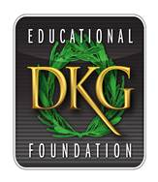
Giving to Educate the World!
  - SPOTLIGHT on
  - The DKG Educational Foundation

How do you want to impact tomorrow? Paying it forward sounds fantastic but sometimes our intentions and actions do not create reality. Anytime you would like to make a difference for educators, members and non-members, please go to the website www.dkgef.org and donate. Each member can make an impact in the world.

DUE DATES -- Apply for grants & awards.
JANUARY:
Project grants to benefit children and education. Available to DKG members and non-members.
FEBRUARY, MAY, and SEPTEMBER:
Lucile Cornetet Individual Professional Development Individual Awards
NOVEMBER:
Lucile Cornetet Individual Professional Development Seminar Awards

Go to the website for information and the applications. Fill in application completely and apply early.

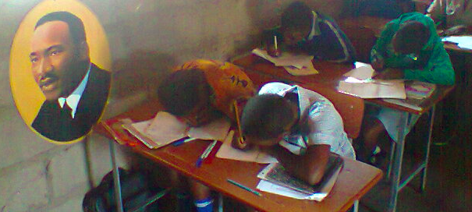 |  | Students in Zimbabwa-----  Grants can be used to provide for education and to benefit students internationally.
Excited about Learning  Are you interested in learning more or enhancing your career goals. Laura applied and received a Cornetet Individual Award to achieve her goals. |  | 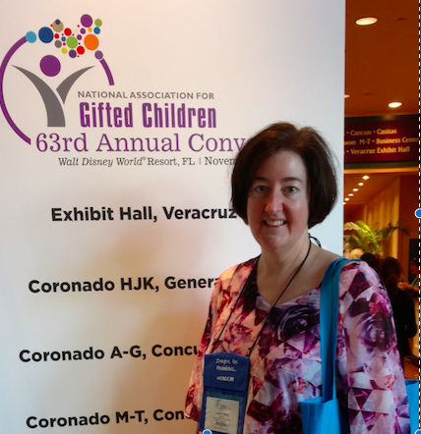
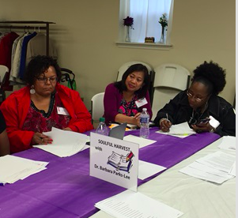  4-State ARTS Collaboration  District of Columbia, Delaware, Maryland, and Pennsylvania decided to work together. They applied and received a Cornetet Seminar Award. |  | 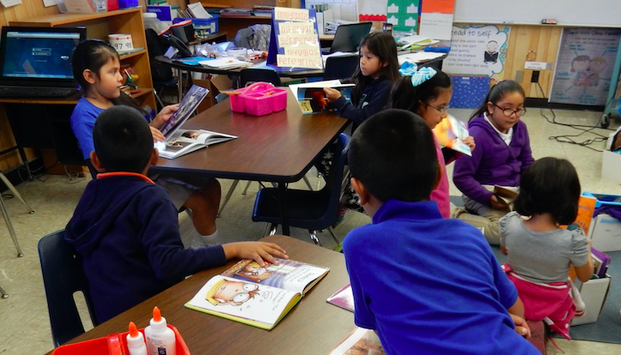  Project Texas  Young career educators used books with children provided by a projects grant.

