History of Omega State

The first chapter in Colorado was Alpha and was organized on March 9, 1937, at the home of Hildegard Sweet (one of our scholarships is named for this remarkable woman). Since that time, Omega State has grown to 29 chapters and approximately 800 members.

Benefits of membership

Omega State Scholarships:
- Hildegard Sweet and Katherine S. Glendinning Scholarship for those earning a PhD.
- Omega State Scholarship for those earning a Master’s Degree
- The Elderhostel Scholarship for those who wish to travel and learn at the same time
- The Lifelong Learning Scholarship for attendance at conferences.

International Scholarships
- Educational Foundation supports education worldwide
- Emergency Fund—national disaster help for members
- World Fellowship—gives educational opportunities for students in other countries
- DKG Gallery of Fine Arts—gives member an opportunity to show their creative sides
Local Chapter Page

Suggestions:
- chapter calendar
- chapter projects
- chapter contacts/officers

Purposes of Delta Kappa Gamma
As members of the Society we have agreed to be loyal and to actively support the seven purposes upon which Dr. Annie Webb Blanton founded the organization in 1929.
The activities of each level of the Society implement the purposes of the Society.
- To unite women educators of the world in a genuine spiritual fellowship
- To honor women who have given or who evidence a potential for distinctive service in any field of education.
- To advance the professional interest and position of women in education
- To initiate, endorse, and support desirable legislation or other suitable endeavors in the interests of education and of women educators
- To endow scholarships to aid outstanding women educators in pursuing graduate study and to grant fellowships to non-member women educators
- To stimulate the personal and professional growth of members and to encourage their participation in appropriate programs of action.
- To inform the members of current economic, social, political, and educational issues so that they may participate effectively in a world society.

Publications:
• The Delta Kappa Gamma International Journal
• The Delta Kappa Gamma Collegial Exchange
• DKG Bulletin
• Omega Peaks Newsletter

Delta Kappa Gamma Website
https://www.dkg.org

Omega State Website
dkgcolorado.weebly.com
Omega State
2017–2019: Praise and Possibility

Colorado Chapter of Delta Kappa Gamma

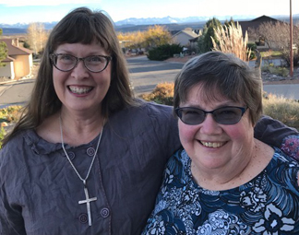
Delta Kappa Gamma is an international professional honor society of key women educators in the United States, Canada, Europe, Latin America, and Japan.

Janet McClaskey, Delta Kappa Gamma International Omega State President and Leila Koenig, First Vice President
MISSION STATEMENT
The Delta Kappa Gamma Society International promotes professional and personal growth of women educators and excellence in education
VISION
Leading women educators impacting education worldwide.

